|  |  |  |
| --- | --- | --- |
| **Assignment** | **:** | **Systems Programming and Computer Control** |
| **Module Code:** | **:** | **CT047-3-2** |
| **Date Assigned** | **:** | **Week 3** |
| **Date Due** | **:** | **Week 10** |

A company has received a contract to produce a security system for a local manufacturer. The purpose of the security system is to monitor the perimeter of the manufacturing complex to prevent unauthorized personnel from entering the grounds. Your job is to design the security system using LabVIEW that satisfies the provided specifications.

**Instructions:**

* Document your assumptions either in your Document or on the LabVIEW block diagram.
* The assignment requires you to develop a LabVIEW application based on a set of specifications.
* A computer with a standard installation of LabVIEW is the only reference allowed for the assignment. Externally developed code and third-party tools are not allowed in the assignment.
* You are to submit your finished application online via Moodle.
* Total time allocated for the assignment is 7weeks

**Grading:**

The application development assignment consists of a total of 50 points (100%) which are allocated as follows:

|  |  |  |
| --- | --- | --- |
| **Criteria** | **Points** | **Percentage %** |
| Programming style | 15 | 30 |
| Functionality | 15 | 30 |
| User InterfaceDesign | 5 | 10 |
| Conformity to design standards | 5 | 10 |
| Documentation | 10 | 20 |

A presentation will follow to allow students to showcase the full functionality of their application. The goal of this presentation is to ascertain that the application submitted is the intellectual product of the student.

**IMPORTANT:**

* **When you have completed the Assignment, submit the assignment document as a MS Word Document(do not zip the file) in documentation folder, and the S/W (along with any other resource) as a Zip file in codes folder**
* **Submit the files on Moodle.**

**Application Development**

**Section I: General Requirements**

The application should:

* Function as specified in **Section II** of this document.
* Conform to LabVIEW coding style and documentation standards (found in

LabVIEW documentation – LabVIEW Development Guidelines).

* Be created using VIs and functions available in LabVIEW (templates, examples, or code developed outside the core functions of LabVIEW are not acceptable).
* Use a state machine that either uses a type defined enumerated control, queue, or

Event structure for state management.

* Be easily scalable to add more states / features without having to manually update

the hierarchy.

* Minimize the use of excessive structures, variables (local / global) and Property

Nodes.

* Respond to front panel controls (within 100 ms) and not utilize 100% of CPU

time.

* Close all opened references and handles where used.
* Be well documented and include the following:
* Labels on appropriate wires within the main VI and sub VIs.
* Descriptions for each algorithm.
* Documentation in VI Properties » Documentation for both main VI and sub VIs.
* Tip strip (tool tip) and Description for front panel controls and indicators.
* Labels for constants.

**Section II: Application Requirements Security System**

**Instructions:**

Using a front panel similar to the graphic provided, create a LabVIEW application that implements the actions of the security system. You will create the software for six perimeter zones, with the actual hardware being simulated by Boolean switches on the Front Panel. The application should be easily scalable to add more zones without having to manually update the hierarchy.

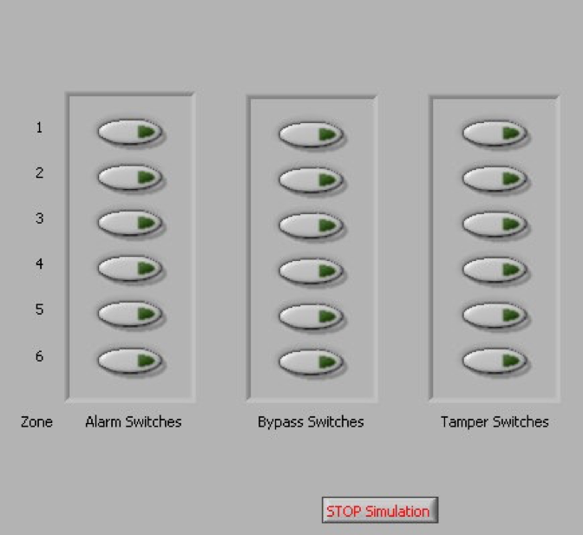

*Client* *Server*

**Definitions:**

Zone: A perimeter area with its own security status indication

Alarm: A zone condition indicating an intrusion into a zone

Bypass: A state in which a zone will not indicate an alarm condition. Placing a zone in bypass prevents nuisance alarms when maintenance work is performed in the area near the perimeter fence, or when severe weather may cause false alarms.

Tamper: A condition where the wiring of a zone has been altered in some way. All zone wiring is supervised. That is, if an individual attempts to circumvent the system by altering the wiring, that zone will indicate a tamper condition.

**Description of Controls/Indicators**

The security system software accepts Boolean inputs, via front panel switches (one set for each zone) for the following functions:

* Alarm input
* Tamper input
* Bypass input

The security system provides for one indicator light for each zone. The colour of the light provides the status information for that zone. The colours are:

* Green: Normal
* Red: Alarm
* Blue: Bypass
* Orange: Tamper

**Operation of the Security System**

System

* The system should be a Client/Server application (as labelled).
* The Client side should transmit signals to the Server side via a TCP/IP connection.
* A Bypass input should always override an Alarm input but should not turn off an existing Alarm condition. An Alarm condition should not be indicated while a zone in a Bypass condition.
* A Tamper input should always override both an Alarm input and/or a Bypass input but should not turn off existing Alarm and/or Bypass conditions. Alarms and Bypass conditions should not be indicated while a zone is in a Tamper condition.
* An existing condition should be indicated when an overriding input is removed.

**File Logging**

The security system should produce an ASCII disk file in a spreadsheet-readable format on the **Server** side. The data, when imported into a spreadsheet, should be in the following format: (where XXXX represents logged data)

|  |  |  |  |
| --- | --- | --- | --- |
| Date | Time | Zone | Status |
| XXXXXXX | XXXXXXX | XXXXXXX | XXXXXXX |
| XXXXXXX | XXXXXXX | XXXXXXX | XXXXXXX |

The status field should contain a string indicating the condition of the zone: Normal, Alarm, Bypass or Tamper.

The log file should be stored in a location relative to the location of the security application and should be updated (appended) only when the status of a zone changes and closed after every transaction.

### Marking Criteria

The assignment will contribute **50%** towards the entire grade of the Module, as mentioned in the Module Descriptor.

**Distinction**

Demonstrated comprehensive research with detailed evidence. High level of analysis performed, exceptional and thorough knowledge and understanding displayed with regard to application. This includes analysis and evaluation of facts followed by results of evaluation. Documentation presented in a professional manner, following proper sequencing and flow. Displayed evidence of critical appraisal. High level of listing citation and references.

**Credit**

Adequate research conducted with fair detail of evidence presented. Moderate level of understanding, analysis and knowledge displayed. Some level of relevance included in terms of application. Moderate level of analysis and evaluation of facts followed by results comparison. Good level of documentation presented. Some level of reflection was evident in the documentation. Moderate level of listing citation and references.

**Pass**

Low level research conducted. Some evidence of research displayed. Basic level of understanding and knowledge analysis displayed. Satisfactory level of documentation. No evaluation and analysis of facts, no results comparison performed Satisfactory or low level of reflection displayed. Low level of listing citation and references.